**CTF Challenge: Enumeration**



**What is Enumeration?**

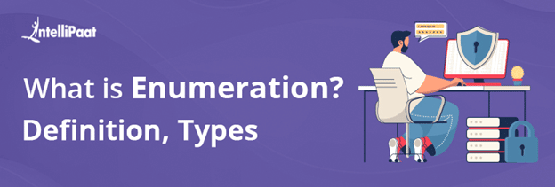

Enumeration in cybersecurity refers to the process of gathering information about a target system or network by systematically exploring its resources. Imagine it as a digital detective meticulously collecting clues about a system, like usernames, services running, or network shares. This information can then be used to identify potential vulnerabilities or gain unauthorized access.

Here's a breakdown of enumeration and its role in attacks:

**1. Purposes of Enumeration:**

* **Identify Attack Vectors:** By enumerating resources, attackers can discover exploitable weaknesses in the system, such as weak passwords, outdated software, or misconfigured services.
* **Gain Access:** Enumeration can help attackers identify valid usernames and passwords, network shares, or other resources that can be used to gain unauthorized access to the system.
* **Maintain Persistence:** Once attackers gain initial access, they might use enumeration to find ways to maintain persistence within the system, allowing them to stay hidden and continue their malicious activities.

**2. Techniques of Enumeration**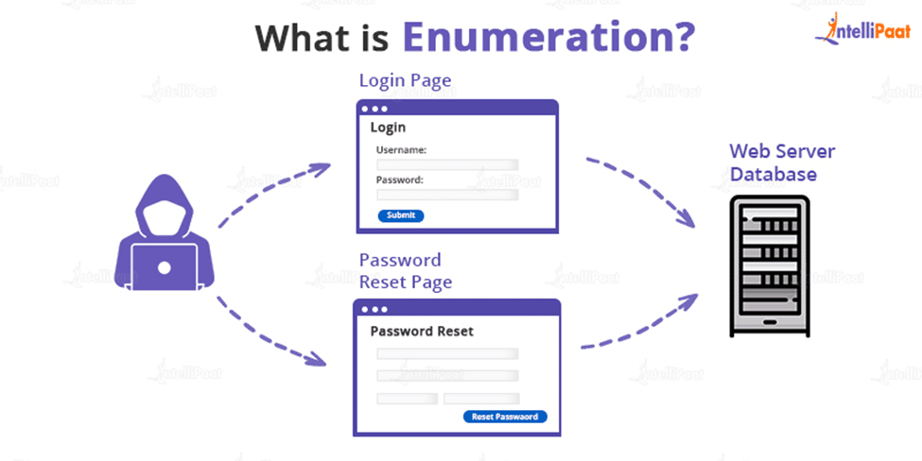

* **User Enumeration:** Techniques are used to identify valid usernames on the system. This might involve exploiting directory listings, password reset mechanisms, or social engineering tactics.
* **Service Enumeration:** Attackers can identify the services running on a system by scanning ports or analyzing network traffic. Knowing the services can help them exploit vulnerabilities specific to those services.
* **Share Enumeration:** Techniques like directory traversal attacks can reveal hidden network shares that attackers can exploit to access sensitive data.
* **Information Gathering:** Attackers might use various methods to gather general information about the system, such as its operating system, software versions, and security configurations.

**3. Defenses Against Enumeration:**

* **Implement Strong Password Policies:** Enforce complex passwords and limit password attempts to thwart brute-force attacks.
* **Minimize Exposed Services:** Disable unnecessary services and keep software updated to patch vulnerabilities.
* **Restrict Access:** Implement access controls to limit user access to only the resources they need.
* **Monitor Network Activity:** Monitor network traffic for suspicious activity that might indicate enumeration attempts.

# **Capture the Flag (CTF) Challenges**

Flag 1. By enumerating resources, attackers can discover what:

Answer: Weaknesses

Flag Captured

Flag 2. Gain Enumeration helps attackers identify what to gain access?

Answer: Credentials

Flag Captured

Flag 3. Techniques used to identify valid usernames on a system are called what enumeration?

Answer: User

Flag Captured

Flag 4. Techniques like directory traversal attacks aim to reveal what through enumeration?

Answer: Shares

Flag Captured